**FOOD ANALYSES PARACTICAL MASTER**

-----------------------------------------------------------------------------------------------------

**Sampling procedures**

**Homogeneus Versus and Hetrogeneous population**

An ideal society would be a society that is similar and identical in its units, and it is easy to draw samples from such a society, as a representative sample can be taken from any part of the society. An example of this is taking a sample of liquid nitrogen gas used for freezing purposes. The matter differs in the case of heterogeneous communities, which is the most common situation in the field of food. In order for the analysis results to be correct, samples must be taken from specific, distributed locations within the heterogeneous community. It may also be necessary to prepare samples in a special way. It goes without saying that the greater the heterogeneity of the food, the more difficult it becomes, and therefore the effort required to prevent taking a sample that does not represent the food, that is, to ensure that the sample drawn is a true representation of the reality of the food. Location of analysis.

**In order to ensure that a representative sample of the total food is taken, three basic conditions must be met:**

* It is necessary to take an appropriate amount of sample with the intention of reducing the compositional variation mentioned above. In this regard, it is recommended to take a number equal to the square root of the total number of packages in the case of packaged foods.
* The sample must be drawn randomly.
* Preventing any change in the composition or properties of the withdrawn sample, such as losing or gaining moisture, or becoming decomposed or contaminated with microbes.

**Type of Sampling Technique**

**1-Manual Sampling Technique:**

* To obtain a hand sample, the person sampling should attempt to take a “random sample” to avoid bias in the sampling process. Therefore, the sample must be taken from several parts of the community or batch to ensure that it represents the entire community.
* For apparently homogeneous materials, such as well-mixed liquids or powders, they must be mixed well before drawing the sample. If these materials are not available in large quantities, they can be mixed by shaking inside a closed container with a volume equal to twice the size of the sample. Also, the mixing process can be performed by repeating Pour the sample several times from one vessel to another.
* As for powders and grains, the mixing process can be carried out using a sample divider, where the grain sample is placed in the hopper located at the top of the divider, then the sample is allowed to descend to the sides of a cone located directly below the center of the hole. There are three holes around the base of the cone and the grains fall onto The sides of the cone are divided into thirty-six separate directions, which are finally gathered in two main directions, each of which flows into a sample collection vessel.

**Thief:**

The thief is a regular or telescopic tube that ranges between 61-91 cm in length and 4.4 cm in diameter. The tube can be extended and is equipped with a false bottom that can be opened and closed to allow samples to be obtained from different heights inside containers such as barrels. The thief is used to withdraw liquid samples.

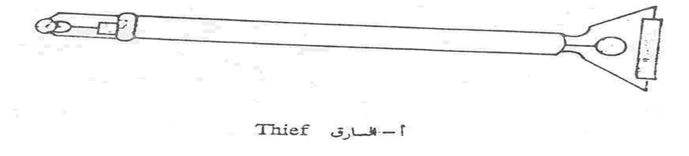

**Trier:**

The tamper has different shapes. It may resemble a shovel with a handle, be in the shape of a pen, or be divided to prevent the sample from falling. The tamper is used to withdraw

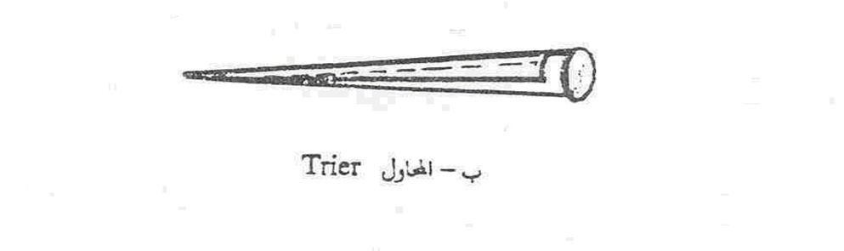

**Sampling Tube:**

This tube can be either simple or compound. The latter consists of two interlocking cylinder halves. The tube can be opened and closed using a handle. The tube is placed inside the whole food while it is closed. Then the handle is turned and the tube is opened, filled with the sample, then closed and withdrawn. A sampling tube is used to withdraw grains and legumes. This tube is usually about 91 cm long and 3.2 cm in diameter.

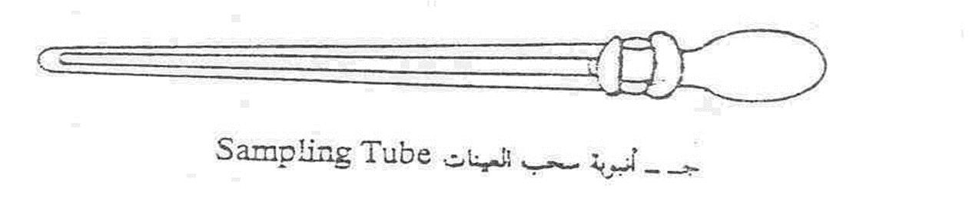

Sampling Screw:

This auger is used to withdraw samples of oilseeds such as cotton seeds and soybean seeds. There is a special auger for each type of seed, as the size of the auger holes varies depending on the size of the seeds.

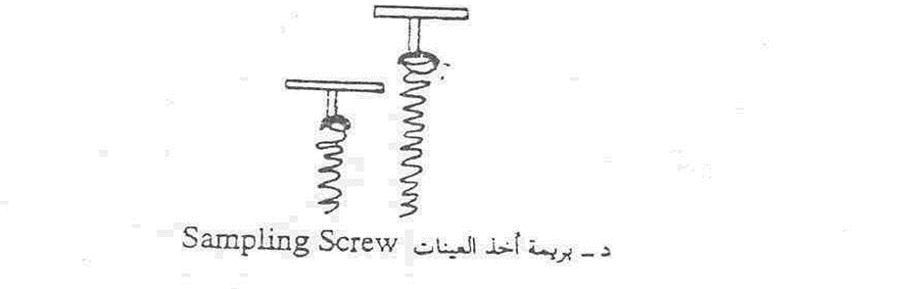

**Sampling Knife:**

This knife is used to sample frozen foods, dry cheese, or semi-solid foods, and the knife is made of stainless steel.

**The drilling**

The drilling machine is a steel cone with serrated ends. This machine is used to take samples of frozen food or dry cheese. The drilling machine is placed on the surface of the food from which a sample is to be taken, and the auger is rotated, so we obtain a cone of the food substance.

**2-Continuous sampling technique:-**

The manual method of taking samples is not suitable in some cases, such as grain stores, large oilseeds, mills, and continuous manufacturing lines, which requires taking samples in a mechanical or automated way (continuous). Among the tools used to draw samples in a continuous manner are:

Riffle cutter

This fractionator consists of dividers located at equal distances and is designed to be able to withdraw small amounts of sample during its flow. This device is usually used in analysis laboratories in order to reduce large samples.



Circular sampler

This puller is used either intermittently or continuously and is suitable for both wet and dry materials. This drawer is designed to take quantities of the material that move in the form of a stream in the form of a circle, so that a quantity of the material can be taken with each cycle. The quantity of the sample withdrawn is determined by the diameter of the drawer opening, where about 5-10% of the material is withdrawn, and therefore it is usually required to use Another drawer to reduce the sample size. If the sample is homogeneous, the process can be performed intermittently, with the drawer provided with a magnet and a time indicator.

**PREPARATION OF samples of analysis**

If the sample is not fully prepared and prepared before analysis, or if it undergoes many changes during preparation, the results will be unreliable, no matter how much effort is made, and no matter how accurate the device and the method are.

**Size Reduction**

* If the particle size or mass of the sample is too large to be used in the analysis, the size must be reduced to the extent that allows the analysis to be performed. To obtain a smaller quantity for analysis, the sample can be spread on a clean surface and divided into quarters, from which two opposite quarters are taken and mixed well, then the process is repeated several times to obtain an analysis sample. This method can be modified to apply to homogeneous liquids by pouring them into four containers, and this method can be performed automatically.

The American Association of Official Chemist Analysts (AOAC) has prepared details for preparing samples of specific foods intended for analysis, depending on the nature of the food substance and the type of analysis required. There are many important preparatory operations that the analyst performs as needed. The meat is completely removed from the bones, and care must be taken not to use small samples, as this leads to the loss of moisture from the small meat samples during preparation and other operations that follow. Minced meat samples should be stored in glass or similar containers with tight lids. Samples of fresh, dried and smoked meat, after separating the meat from the bones, are passed three times through a meat grinder whose openings do not exceed 3 mm. Then mix the sample well and analyze it immediately afterwards. If this is not possible, keep the sample refrigerated in an airtight glass container. If you want to store them for long periods, samples can be dried or frozen.

* As for solid foods that contain sugar, the sugar sample must be ground and mixed well using a spatula, and small lumps should be broken using a mortar and the mortar hand.
* As for fresh fruits and vegetables, the soil or sand related to them should be removed, washed or wiped with a wet cloth. It should be remembered that frequent washing may lead to the loss of some dissolved solids. Large fish are cleaned and their scales and entrails are removed, while small fish are used entirely. Liquid eggs are separated from the shell, and any suspended materials or visible sediments in the fruit juice are removed by filtration. As for canned fruits and vegetables, they are separated into their solid and liquid parts using a sieve. However, if the total is to be analyzed, the solid and liquid are mixed and mashed. As for marine fish canned in brine or oil, the liquid is also separated from the solid using a sieve.
* Mix all these samples and mix them well before taking the sample for analysis. Liquid foods have their contents mixed while they are inside the bottle or box before analysis. As for the milk, it must be mixed well because the fat floats to the top during waiting times. If it does not become homogeneous when mixed, then the milk is heated to 38°C in a water bath while continuing to mix using a glass rod, then the analysis sample is taken. ​
* As for solid fats, they are melted by heat and filtered while hot to separate foreign substances from them after mixing them well. As for the butter, it is diluted in a water bath and shaken during the dilution to remix any amount of fat separated from it. It is then removed from the water bath and shaken while it cools until a homogeneous creamy consistency is obtained. The represented sample is taken from hard cheese using a drilling machine, while soft cheese is taken by cutting, while dry foods such as flour are mixed by constantly rotating the contents. However, if the powders are clumped together, they must be re-crushed and passed steadily through a sieve, with extra care not to change the moisture content during this process. the operation.